**EXPERIMENT-5**

# AIM:

# Study and implement the Multinomial Naive Bayes on spam ham dataset

# ALGORITHM:

1. In the first step, feature engineering, we focus on extracting features of text. We need numerical features as input for our classifier.
2. In the non-naive Bayes way, we look at sentences in entirety, thus once the sentence does not show up in the training set, we will get a zero probability, making it difficult for further calculations.
3. In the final step, we are good to go : simply calculating the probabilities and compare which has a higher probability

# PROGRAM CODE SNIPPET:

## LOADING DATA SET:

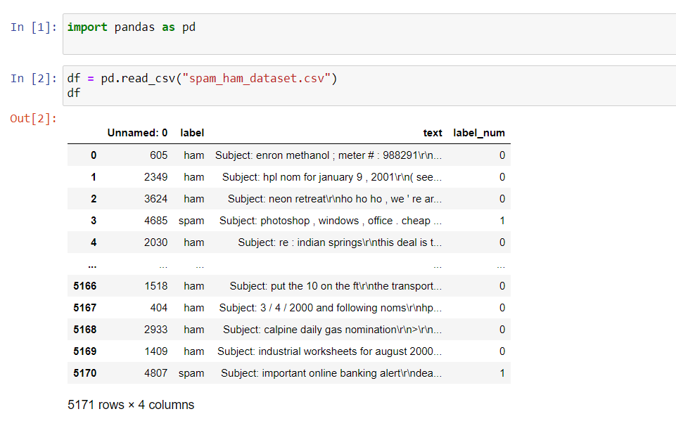

## PREPROCESSING:

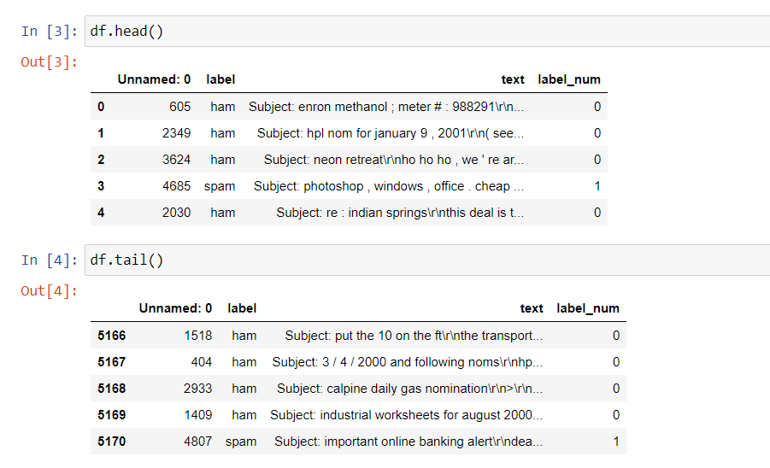

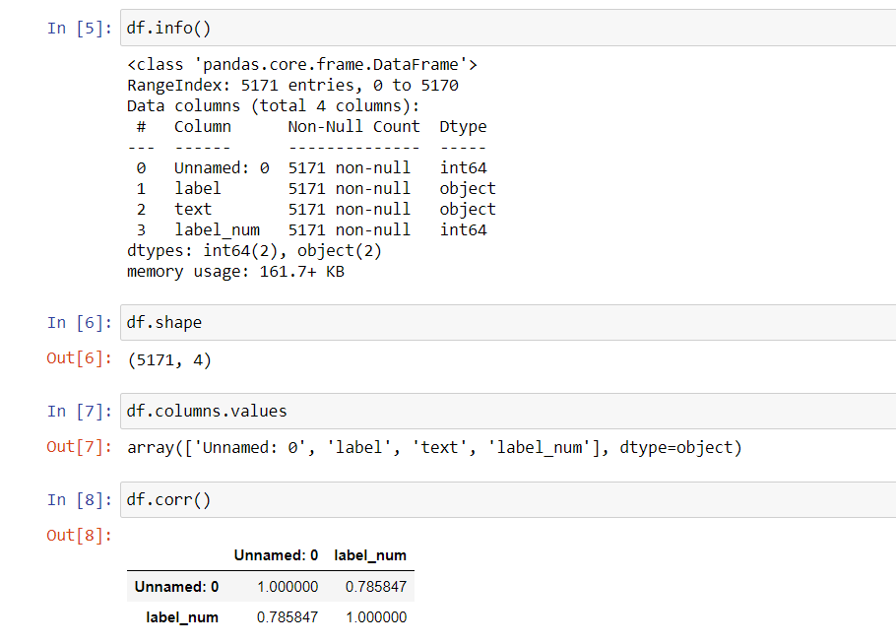

## VISUALIZATION:

